Laboratory 4 – Week 4
Conditional Statements

Introduction

Firstly, this worksheet is one of the worksheets from which your laboratory portfolio will be assessed [CodeRunner exam].

This laboratory session covers conditional statements in Java. We will be implementing some of the examples given during the lecture, followed by some additional examples. We will then look at a few sections of the help pages.

Preliminaries

Today’s seminar activity will revolve around completing our first CodeRunner quiz. The tests can be accessed from a university machine or via Brunel Horizon (through Brunel Connect). The tests are web browser based and can be run by opening the following URL and logging in with your eVision username and password:

https://coderunner.brunel.ac.uk



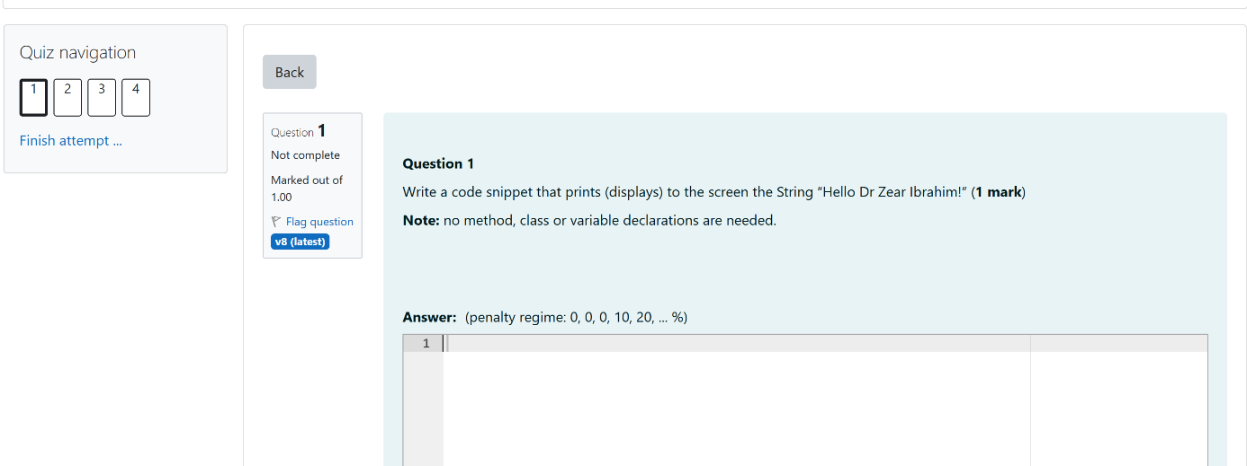

You paste the code as instructed into the text box. You can check your solution by clicking the “Check” button, however you have a number of FREE checks, further checks will reduce the marks that you can get for the question by 10%, 20%, etc…You are encouraged to test your code thoroughly in Eclipse before checking it on the CodeRunner platform. Refer to the CodeRunner tutorial videos released for examples on how to test your code.

When you click “Next” you will be moving on to the next question. You can navigate back to previous question(s) using the navigation bar at the top. When you have done all of the questions the “Next” button will be replaced by “Finish attempt…”. You will be taken to a summary screen where and then you must click “Submit all and finish” to see how well you have done. You must click this button or none of your answers will count.

What are Conditional Statements?

A condition is an expression that can be evaluated to either true or false. We use conditions to make decisions in specific scenarios. For instance, in natural language we could say:

$$"If it's raining, bring an umbrella"$$ | (1)

To represent this natural language expression mathematically, we could represent the weather as a variable, and assign numeric values to different conditions, like so:

$$x=1 (raining),$$  $$x=2 (sunny)$$ | (2)

We can now represent this logic as a conditional statement using a mathematical piecewise function:
$$f\left(x\right)=\left\{\begin{aligned}bring umbrella, &if x=1 \\ no umbrella, &if x=2\end{aligned}\right.$$ | (3)

Equation (3) presents a function $f\left(x\right)$ which defines what action to take based on the input value of $x$. It says to bring an umbrella $if x=1$ or no umbrella $if x=2$.

Conditions in Programming

Programmatically, conditional statements such as the one defined in Equation (3) become a construct that allows us to control the flow of a program based on whether the condition is true or false. It works by testing a condition and then executing different code based on the result.

Create a new Java project called Lab4, and class called CheckWeather.java.

public class CheckWeather {

public static void main(String[] args) {

// Define the weather as raining
int x = 1;

// Check the variable
if (x == 1) {
System.out.println("Bring an umbrella.");
} else if (x == 2) {
System.out.println("No need for an umbrella.");
} else {
// What is this 'else' for?

}
}
}
Run this program and take a note of the output in the console. What happens if you set the variable $x$ to a value that the condition does not check for (i.e., $x=3$) ?

Bring an umbrella. Changing x to 3 causes the program not to print anything.

In scenarios where the conditional statements do not explicitly define an action for a given input variable, we can include an ‘otherwise’ case to handle those unspecified conditions.

$$f\left(x\right)=\left\{ \begin{aligned}bring umbrella, &if x=1 \\ no umbrella, &if x=2 \\ unknown condition, &otherwise\end{aligned}\right.$$ | (4)

Fill in the remaining ‘else’ block with a system print to handle unknown values and run the program again.

Relational Operators

Note that in the CheckWeather.java program we defined an integer int x = 1; and later wrote the conditional statement if (x == 1), what do you think the difference between the single equals operator (=) and the double equals operator (==) is? Fill in the table below and inspect the remaining definitions.

Operator | Description | Example | Meaning
= | Assignment Operator | x = 5 | Sets the value of x to 5
== | Equality Operator | x == 5 | Checks if x is equal to 5
!= or (≠) | Inequality Operator | x != 5 | Checks if x is not equal to 5
< | Less Than Operator | x < 5 | Checks if x is less than 5
> | Greater Than Operator | x > 5 | Checks if x is greater than 5
<= or (≤) | Less Than or Equal To Operator | x <= 5 | Checks if x is less than or equal to 5
>= or (≥) | Greater Than or Equal To Operator | x >= 5 | Checks if x is greater than or equal to 5
Table 1: Relational Operators

Compound Conditions

It is also possible to “compound” conditions, i.e., join them together in one expression. For instance, the natural language expression:
$$"If it's raining AND snowing, there will be sleet"$$ | (5)
We can mathematically represent this by creating two variables for weather, where $x$ is to represent rain and $y$ to represent snow.
$$f\left(x,y\right)=\left\{\begin{aligned}there will be sleet, &if (x=1)∧(y=1) \\ no sleet, &otherwise\end{aligned}\right.$$ | (6)

In Equation (6), the function $f\left(x,y\right)$ takes two inputs which are evaluated one after the other. We use the logical AND operator $(∧)$ to represent that both values must resolve to true (i.e. 1) for the specific action of “there will be sleet” to be executed. Programmatically, we can write:

public class CheckWeather {

public static void main(String[] args) {
int x = 1; // Raining?
int y = 1; // Snowing?

if (x == 1 && y == 1) {
System.out.println("There will be sleet");
} else {
System.out.println("No sleet, perhaps just rain?");
}
}
}
Copy this code into your Eclipse and change the conditional statement above to use an OR operator. Make sure to run this program with different values for raining and snowing. What do you notice?

“No sleet, perhaps just rain?” is only printed when both x and y are set to 0

Based on your results enter the description for both operators.

Programmatical  Operator | Mathematical  Equivalent | Description | Example | Meaning
&& | $$∧$$ | AND Operator | x == 1 && y == 1 | Both x and y must be 1
|| | $$∨$$ | OR Operator | x == 1 || y == 1 | Either x or y must be 1
Table 2: Conditional Compound Operators

Exercises

This lab’s exercises are made up of several sections related to the Week 3 Lecture.

Conditional Compound operators
Write the following programs:
- Displays if a whole number (>0) is divisible by 2 and 3
- Displays if a whole number (>0) is divisible by 7 or 9
- Displays if a whole number (>0) is divisible by 2 and 3 but not 5
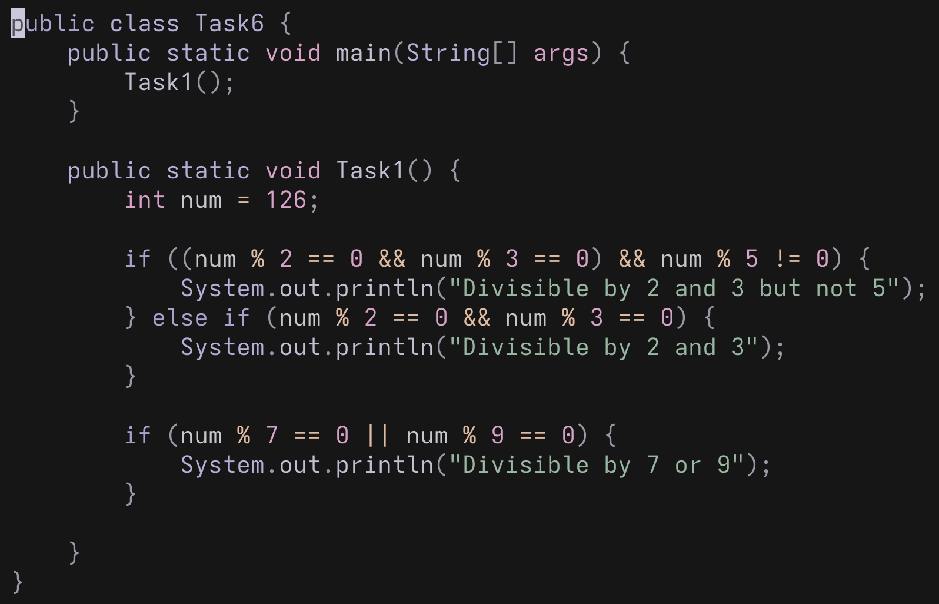
Based on these programs, consider, if an integer $x$ is divisible by an integer $y$, what does that mean? Try your programs on a number of examples.

Click or tap here to enter text.
If you had to rerun your programs on the numbers between 1 and 1000, what issues would you encounter?

It would take an unreasonable amount of time and may run out of memory

Sorting based on conditions

Write the Java code that will solve the following problems:
- Given three numbers, displays them in the correct order (ascending)
- Given three names (e.g. name1, name2 and name3 as string variables), display them in the correct alphabetical order

For example, for the first part of this exercise, if:

a = 10, b = -10 and c = 3

Then the program might output:

The correct order is ‘b’<=’c’<=’a’

Note that your code should work on any three numbers or names, not just one specific example.

The following suggestions might help in writing these small programs:

- Using == may fail, consider using the built in String function CompareTo()
- You could assume that the three numbers will be stored as three variables, named for example, a, b and c.
- When writing these programs, you should try and design your program first, i.e. it might be useful to try and write the flow chart for the program (https://www.draw.io/).
- Test any design (or program) you write with some test data.
- The second program (2) might be solvable by using (copying and modifying) the code from the first one (1)

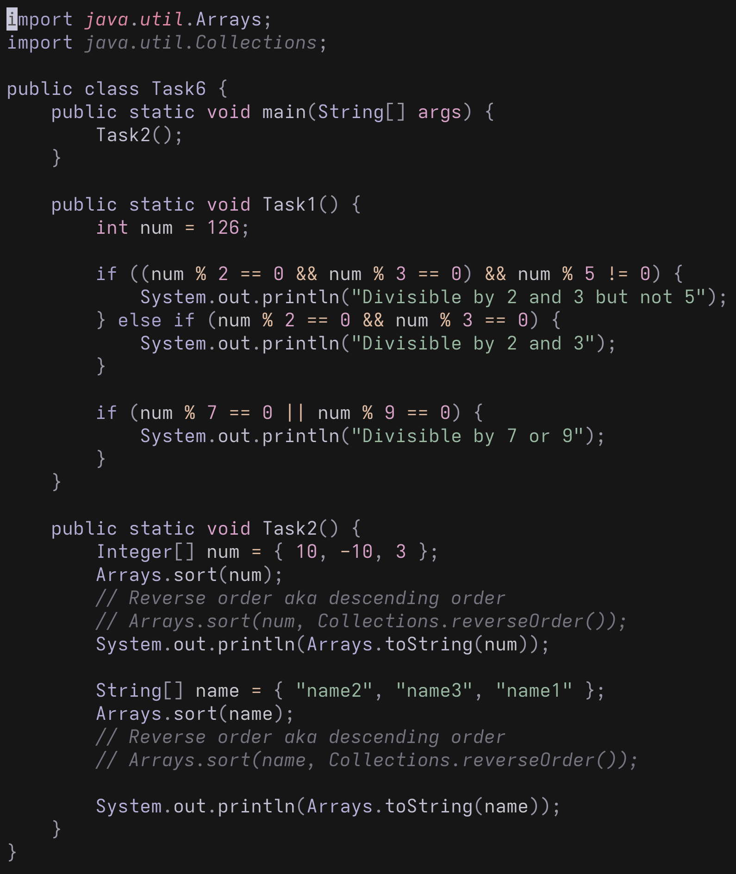

Once you have got your program running, have a think about the following:

- How easy would it be to change your program so that it reverses the order?

Quite easy as all you have to do is pass Collections.reverseOrder() to the Arrays.sort() function

- What modifications would be needed to make your program work for 10 numbers? What about 1000? What are the implications of this?

None

Using Switch Statements

Considering that piecewise functions that can be used to represent cases, another way to represent them are using switch statements with individual cases. Copy and paste the following example into a new class and run it.

String month = "September";
int daysinmonth = 0;

switch(month)
{
case "January":
daysinmonth = 31;
break;
case "February":
daysinmonth = 28;
break;
case "March":
daysinmonth = 31;
break;
case "April":
daysinmonth = 30;
break;
case "May":
daysinmonth = 31;
break;
case "June":
daysinmonth = 30;
break;
case "July":
daysinmonth = 31;
break;
case "August":
daysinmonth = 31;
break;
case "September":
daysinmonth = 30;
break;
case "October":
daysinmonth = 31;
break;
case "November":
daysinmonth = 30;
break;
case "December":
daysinmonth = 31;
break;
default:
daysinmonth = -1;
break;
}

System.out.println("Days in month " + month + " = " + daysinmonth);

This program should display the days in a month for a given variable month. Copy and run the code. Change the month variable to a number of different valid and invalid values.

The code is slightly cumbersome and bloated, with lots of repetition. Also note that I have not included the braces for the main and class (“{}”), this was to save space. Make sure you put them in!

Now consider the following modified version:

switch (month)
{
case "January": case "March": case "May": case "July": case "August": case "October": case "December":
daysinmonth = 31;
break;
case "February":
daysinmonth = 28;
break;
case "April": case "June": case "September": case "November":
daysinmonth = 30;
break;
default:
daysinmonth = -1;
break;
}
System.out.println("Days in month " + month + " = " + daysinmonth);

Check that the program runs in the same manner as the previous version. Notice how we can group similar cases together on the same line, thus reducing space and aiding readability.

Write a similar pair of programs to the two above that use a switch statement to determine the number of legs a creature has (stored in a String in a similar manner to the month variable above). Remember to print the name of the creature as in the first switch statement.

The animals the program should cater for are as follows:

Alsatian Dog, Sphynx Cat, Cobra, Baboon, Centipede, Ocelot, Cod, Human, Tarantula, Black Scorpion, Paul Allen the German Octopus, Minke Whale, Klingon and Potto

Remember to have a default option in your program.

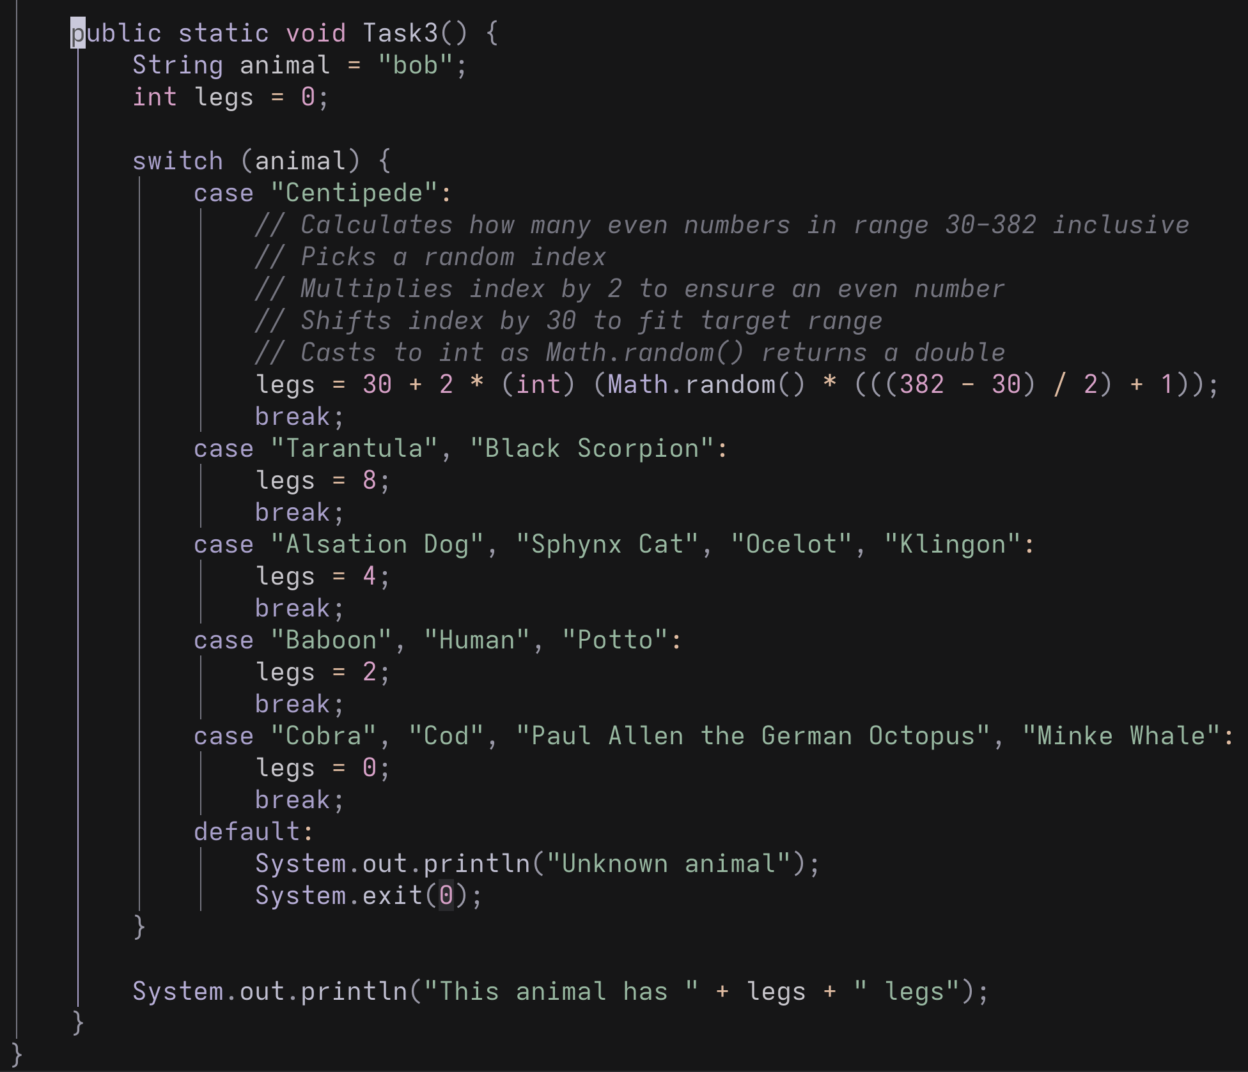

The Ternary Operator (?: If Notation)

Finally rewrite all of your answers to section 4.5.1 using the ternary operator (?: if notation). Which style do you think is better and why?

https://www.w3schools.com/java/java_conditions_shorthand.asp

